Cleaning up the Great Lakes
Name
Institution

Introduction
The Great Lakes cleaning project involves the calculation of the rate of change of a pollutant in a liquid mass based on the inflow and outflow of the liquid into an irregular reservoir. The paper uses Matlab to calculate how long it will take to decrease, by a fixed percentage, pollutants from four adjacent lakes with inflows and outflows. Matlab was used to make the calculations.

Part 1
Time in years that is expected to take to clear all the pollution out of the Great Lakes. This was calculated by multiplying each great lakes size in $mi^{3}$by the rate of water outflow. Below are the calculations results.

Lake Superior
$2900 mi^{3}*1 year/19 mi^{3}=152.63 years$
Lake Michigan
$1200 mi^{3 }*1 year/36 mi^{3}=33.33 years$
Lake Huron
$$900 mi^{3}*1 year/75 mi^{3}=12 years$$
Lake Erie
$120 mi^{3} * 1 year/97 mi^{3 }=1.24 years$
Lake Ontario
$400 mi^{3}* 1 year/111 mi^{3}=3.60 years$

Part 2
We assumed that each lake was an independent tank holding clean water. Based on this assumption, we calculated the length of time that it would take for each of the lakes to attain a point of 50% and 5% pollution. In the second part, we assumed that only fresh water was flowing into the lake. Using this approach, we calculated the length of time that it would take to remove 50% and 5% pollution.

Lake Superior:
50%=> $ds/dt= (-19/2900)*S$ $∫ds/S=∫(-19/2900)*dt$ $ln(t)= -19t/2900+C1$ $x1(t)=C1e^{(-19t/2900)}$ $x1(t)=.5*C1$ $.5C1=Ce^{(-19t/2900)}$ $t=ln(.5)*(-2900/19)$ $t=105.80 years$
5%=> $x1(t2)=.05*C1$ $.05C1=C1e^{(-19t/2900t2)}$ $t2=ln(.05)*(-2900/19)$ $t2=457.24 years$
Lake Michigan:

50%=> $ds/dt= (-36/1200)*S$ $∫ds/S=∫(-36/1200)*dt$ $ln\left(t\right)= -36t/1200+C1$ $x1(t)=C1e^{(-36t/1200)}$ $x1(t)=.5*C1$ $.5C1=Ce^{(-36t/1200)}$ $t=ln(.5)*(-1200/36)$ $t=23.10 years$
5%=> $x1(t2)=.05*C1$ $.05C1=C1e^{(-36t2/1200)}$ $t2=ln(.05)*(-1200/36)$ $t2=99.86 years$
Lake Huron:
$50\%=>ds/dt= (-75/900)*S$ $∫ds/S=∫(-75/900)*dt$ $ln(t)= -75/900+C1$
$x1(t)=C1e^{(-75t/900)}$ $x1(t)=.5*C1$ $.5C1=Ce^{(-75t/900)}$ $t=ln(.5)*(-900/75)$
5%=> $x1(t2)=.05*C1$ $.05C1=C1e^{(-75t2/900)}$ $t2=ln(.05)*-900/75)$
$t=8.32 years$ $t2=35.95 years$
Lake Erie:
50%=> $ds/dt= (-97/120)*S$ $∫ds/S=∫(-97/120)*dt$ $ln(t)= -97t/120+C1$ $x1(t)=C1e^{(-97t/120)}$ $x1(t)=.5*C1$ $.5C1=Ce^{(-97t/120t}$ $t=ln(.5)*(-120/97)$ $t=0.86 years$
5%=> $x1(t2)=.05*C1$ $.05C1=C1e^{(-97t2/120)}$ $t2=ln(.05)*(-120/97)$ $t2=3.71 years$
Lake Ontario:
50%=> $ds/dt= (-111/400)*S$ $∫ds/S=∫(-111/400)*dt$ $ln(t)= -111t/400+C1$ $x1(t)=C1e^{(-111t/400)}$ $x1(t)=.5*C1$ $.5C1=Ce^{(-111t/400)}$ $t=ln(.5)*(-400/111)$ $t=2.50 years$
5%=> $x1(t2)=.05*C1$ $.05C1=C1e^{(-111t2/400)}$ $t2=ln(.05)*(-400/111)$ $t2=10.80 years$

 | t1 years: 50% Pollution | t2 years: 5% Pollution
Lake Superior | 105.80 | 457.24
Lake Huron | 23.10 | 99.86
Lake Michigan | 8.32 | 35.95
Lake Erie | 0.86 | 3.71
Lake Ontario | 2.50 | 10.80

Part 3:
In this part, we assumed that pollution could only be removed from the last lake after flowing through all the other three lakes. To do this, we came up with a system of equations. We worked systematically, the same way the water is flowing, from Superior and Michigan to Huron, and then Erie and Ontario.

I.
Lake Superior Equation
ds(t)/dt= $0-(19mi^{3}/yr)(s(t) slugs/mi^{3})/2900mi^{3})$
Lake Michigan
dm(t)/dt=$0-(36mi^{3}/yr$)$(m(t) slugs/mi^{3})/1200mi^{3})$
Lake Huron
$$dh(t)/dt=0+(19mi^{3}/yr)((s(t)slugs/mi^{3})/2900mi^{3})+_{}(36mi^{3}/yr)((m(t)slugs/mi^{3})/1200mi^{3})-(75mi^{3}/yr)((h(t)slugs/mi^{3})/900mi^{3})$$
Lake Erie
$$de(t)/dt=0+(75mi^{3}/yr)((h(t)slugs/mi^{3})/900mi^{3})-(97mi^{3}/yr)((e(t)slugs/mi^{3})/120mi^{3})$$
Lake Ontario
$$dn(t)/dt=0+(97mi^{3}/yr)((e(t)slugs/mi^{3})/120mi^{3})-(111mi^{3}/yr)((n(t)slugs/mi^{3})/400mi^{3})$$

ii.
Matrix form so matlab calculations can be done

-19/2900 0 0 0 0
19/2900 -75/900 36/1200 0 0 X
0 0 -36/1200 0 0
X’= 0 75/900 0 -97/120 0
0 0 0 97/120 -111/400

A =

-0.0066 0 0 0 0 Superior
0.0066 -0.0833 -0.03 0 0 Huron
0 0 -0.03 0 0 Michigan
0 0.0833 0 -0.8083 0 Erie
0 0 0 0.8083 -0.2775 Ontario

iv.
Matlab’s numeric solver function was used to find the level of pollution in each lake. In the case of Lake Superior, with an initial 2900 pollutants, 50% of the pollutant equation would be $(2900/2)=2900e^{-0.0066t}$. These equations were solved using Matlab.

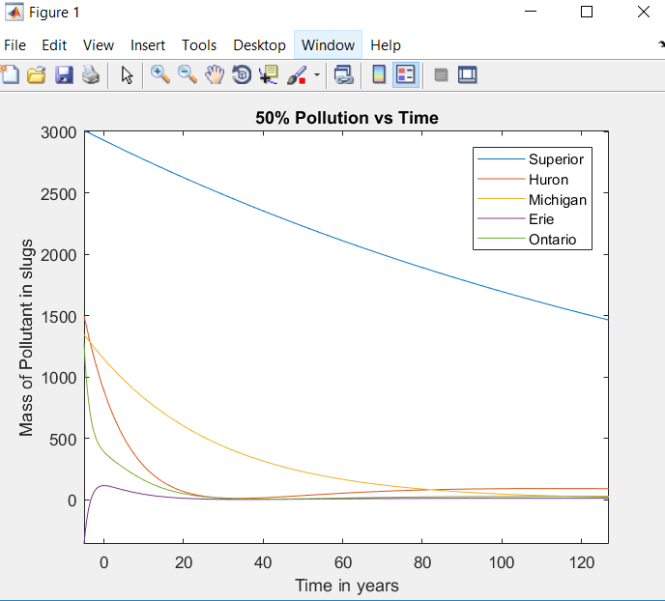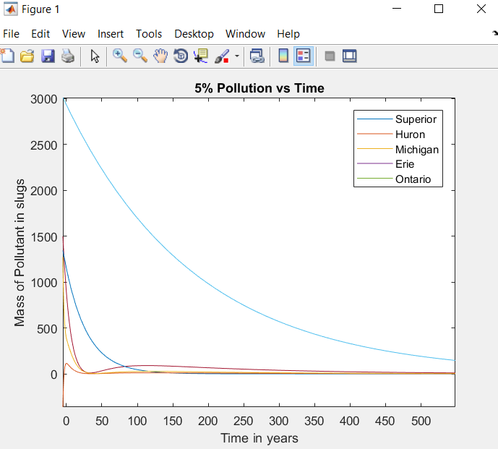

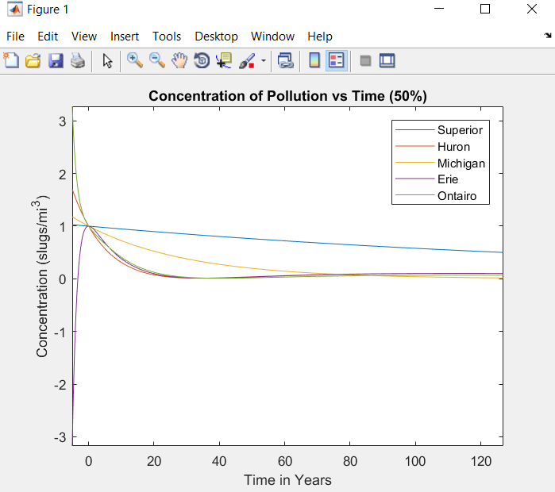
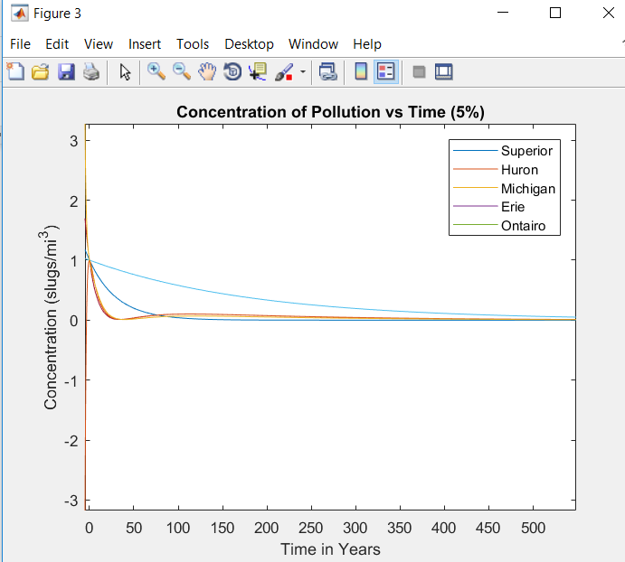

Bibliography
Hunt, B. R., Lipsman, R. L., Rosenberg, J. M., Coombes, K. R., Osborn, J. E., & Stuck, G. J. (2018). A Guide to MATLAB: For Beginners and Experienced Users. Cambridge: Cambridge University Press.

Appendix
Matlab Code
A=[-19/2900,0,0,0,0;19/2900,-75/900,-36/1200,0,0;0,0,-36/1200,0,0;0,75/900,0,-97/120,0;0,0,0,97/120,-111/400];
poly(A);
r=roots(poly(A));
I=eye(5,5);
%Eigen Vectors
r1=evalues(1) ;
r2=evalues(2);
r3=evalues(3);
r4=evalues(4);
r5=evalues(5);
%Eigen Values
u1=null(A-r1*I);
u2=null(A-r2*I);
u3=null(A-r3*I);
u4=null(A-r4*I);
u5=null(A-r5*I);
%Find the constants
B=[u1,u2,u3,u4,u5];
X0=[2900;900;1200;120;400];
C=inv(B)*X0;
%coefficients of eigenvalues for x1
r(1)
x11=C(1)*u1(1);
x12=C(2)*u2(1);
x13=C(3)*u3(1);
x14=C(4)*u4(1);
x15=C(5)*u5(1);
%coefficients of eigenvalues for x2
x21=C(1)*u1(2);

x22=C(2)*u2(2);
x23=C(3)*u3(2);
x24=C(4)*u4(2);
x25=C(5)*u5(2);
%coefficients of eigenvalues for x3
x31=C(1)*u1(3);
x32=C(2)*u2(3);
x33=C(3)*u3(3);
x34=C(4)*u4(3);
x35=C(5)*u5(3);
%coefficients of eigenvalues for x4
x41=C(1)*u1(4);
x42=C(2)*u2(4);
x43=C(3)*u3(4);
x44=C(4)*u4(4);
x45=C(5)*u5(4);
%coefficients of eigenvalues for x5
x51=C(1)*u1(5);
x52=C(2)*u2(5);
x53=C(3)*u3(5);
x54=C(4)*u4(5);
x55=C(5)*u5(5);
%make the equations with these calculated values. Some of these values are
%zero, these were used to get the simplified equations in the report
equations=[x11,x12,x13,x14,x15;x21,x22,x23,x24,x25;x31,x32,x33,x34,x35;x41,x42,x43,x44,x45;x51,x52,x53,x54,x55];
%from the simplified equations we can simplify u in terms of x and asign
%each equation a different variable, it will make things easier
syms t
s=x15*exp(r5*t);
h=x23*exp(r3*t)+x24*exp(r4*t)+x25*exp(r5*t);
m=x34*exp(r4*t);
e=x41*exp(r1*t)+x43*exp(r3*t)+x44*exp(r4*t)+x45*exp(r5*t);
o=x51*exp(r1*t)+x52*exp(r2*t)+x53*exp(r3*t)+x54*exp(r4*t)+x55*exp(r5*t);
%Time for lakes to get to 50% polution
Spol50 = vpasolve(0.5*X0(1)==s,t);
Hpol50 = vpasolve(0.5*X0(2)==h,t);
Mpol50 = vpasolve(0.5*X0(3)==m,t);
Epol50 = vpasolve(0.5*X0(4)==e,t);

Opol50 = vpasolve(0.5*X0(5)==o,t);
%Time for 5% polutant
Spol5 = vpasolve(0.05*X0(1)==s,t);
Hpol5 = vpasolve(0.05*X0(2)==h,t);
Mpol5 = vpasolve(0.05*X0(3)==m,t);
Epol5 = vpasolve(0.05*X0(4)==e,t);
Opol5 = vpasolve(0.05*X0(5)==o,t);
%Plots 50%
figure;
fplot(s);
hold on;
fplot(h);
hold on;
fplot(m);
hold on
fplot(e);
hold on;
fplot(o);
hold on;
plot(Spol50,2900/2,'r');
hold on;
plot(Hpol50,900/2,'b');
hold on
plot(Mpol50,1200/2,'g');
hold on;
plot(Epol50,120/2,'m');
hold on;
plot(Opol50,400/2,'k');
hold on
title("50% Pollution vs Time");
xlabel("Time in years");
ylabel("Mass of Pollutant in slugs");
legend('Superior','Huron','Michigan','Erie','Ontario');
%Plots 5%
figure;
fplot(s);
hold on;
fplot(h);
hold on;
fplot(m);

hold on
fplot(e);
hold on;
fplot(o);
hold on;
plot(Spol5,2900/20,'r');
hold on;
plot(Hpol5,900/20,'b');
hold on;
plot(Mpol5,1200/20,'g');
hold on;
plot(Epol5,120/20,'m');
hold on;
plot(Opol5,400/20,'k');
hold on
title("5% Pollution vs Time");
xlabel("Time in years");
ylabel("Mass of Pollutant in slugs");
legend('Superior','Huron','Michigan','Erie','Ontario');
%Concentration 50%
figure;
fplot(s/X0(1));
hold on;
fplot(h/X0(2));
hold on;
fplot(m/X0(3));
hold on;
fplot(e/X0(4));
hold on;
fplot(o/X0(5));
hold on;
plot(Spol50,0.5,'r');
hold on;
plot(Hpol50,0.5,'b');
hold on;
plot(Mpol50,0.5,'g');
hold on;
plot(Epol50,0.5,'m');
hold on;
plot(Opol50,0.5,'k');

hold on;
title("Concentration of Pollution vs Time (50%)");
xlabel("Time in Years");
ylabel("Concentration (slugs/mi^3)");
legend('Superior','Huron','Michigan','Erie','Ontairo');
%Concentration 5%
fplot(s/X0(1));
hold on;
fplot(h/X0(2));
hold on;
fplot(m/X0(3));
hold on;
fplot(e/X0(4));
hold on;
fplot(o/X0(5));
hold on;
plot(Spol5,.05,'r');
hold on;
plot(Hpol5,.05,'b');
hold on;
plot(Mpol5,.05,'g');
hold on;
plot(Epol5,.05,'m');
hold on;
plot(Opol5,.05,'k');
hold on;
title("Concentration of Pollution vs Time (5%)");
xlabel("Time in Years");
ylabel("Concentration (slugs/mi^3)");
legend('Superior','Huron','Michigan','Erie','Ontario');

